ONE PAGE WORKSHOP HANDOUT (SAMPLE)
(You may also refer to Sample Lesson Plan at bottom of this document)

1. INTRODUCTION

2. SESSION OBJECTIVES

3. TOPIC 1
TOPIC 2
TOPIC 3
TOPIC 4
TOPIC 5
TOPIC 6
TOPIC 7
4. CLOSING

5. RESOURCE MATERIALS (Places to go for more information)

TIME | Steps to A Sample Workshop on teaching beginning guitar
 | INTRODUCTION
3 min | Introduce facilitator/s – name/s and background  Who are you?  What is your connection to this workshop/why are you teaching this workshop?
 | SESSION OBJECTIVES
2 min | What will you be teaching?  What level of musicianship is this workshop geared for?  What instrument is needed?  *(How does one engage people who may show up without an instrument?)
 | TOPIC 1 Beginning chords
5 min (more if participants need more time – depends on their level) | Teach simple C chord  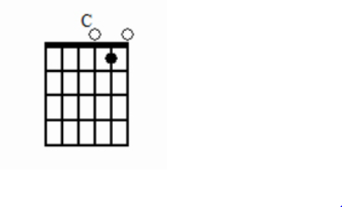
 | TOPIC 2 Beginning Rhythms
5 min  (as above) | Teach quarter note rhythms with downstroke strum, playing C chord
 | TOPIC 3 Play and sing
5 min | Play and sing Row, Row, Row Your Boat with C chord
 | TOPIC 4 More Chords
5 mins | Teach simple G7 chord  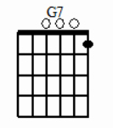
 | TOPIC 5 Switching Chords and Rhythm
5 mins | Play CCCC|G7 G7 G7 G7| back and forth 8 times
 | TOPIC 6 Play and Sing
10 mins | Teach multiple familiar songs that can be played with two chords from a variety of musical genres:  *(Provide individual song sheets with chord changes clearly listed)  For example:  We’ve Got the Whole World In Our Hands  Irish Washerwoman  Singin’ In The Rain  Streets of Laredo  Simple Gifts  Ain’t Gonna Let Nobody Turn Me Around
 | TOPIC 7 3 Chord Principle
15 minutes | Introduce circle of 5ths principle:  C F G7, G C D7, Etc…..
5 mins | CLOSING

